

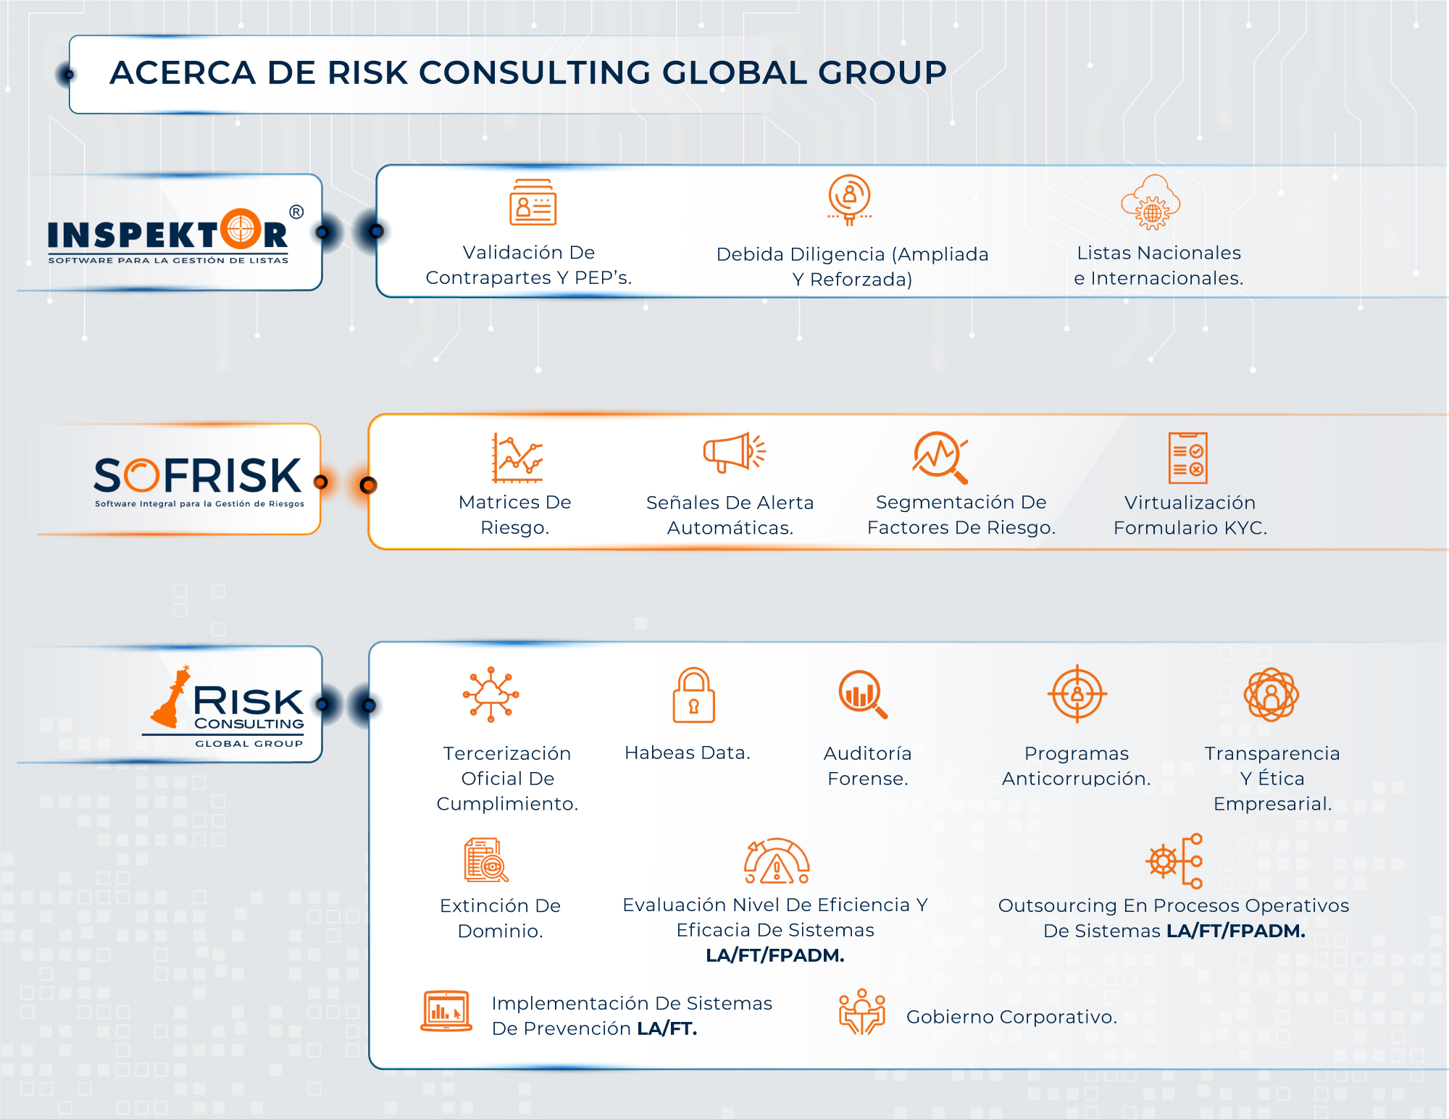

[](https://www.riskglobalconsulting.com/inspektor/)

[](https://www.riskglobalconsulting.com/sofrisk/)

[](https://www.riskglobalconsulting.com/)

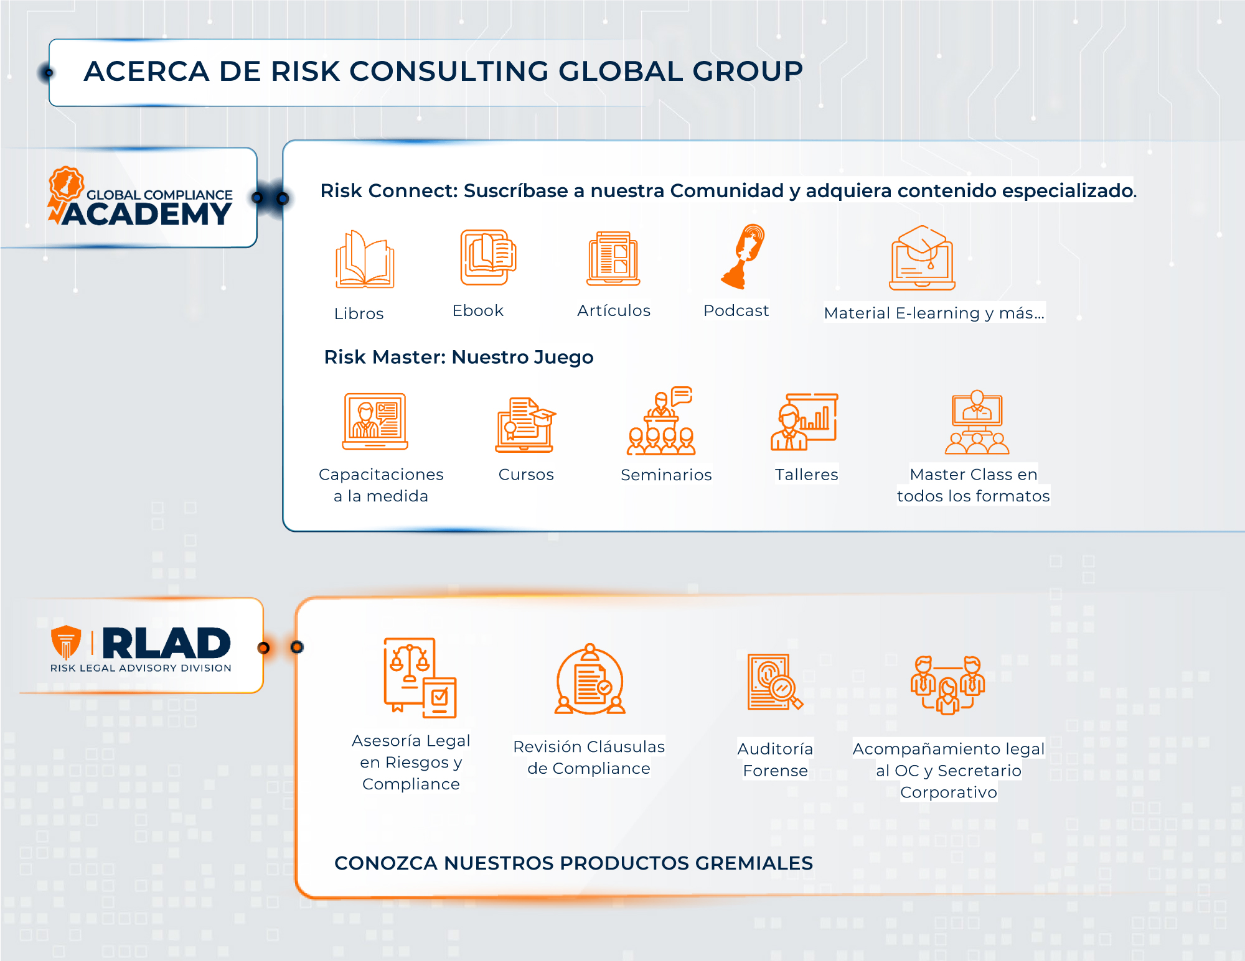

[](https://www.riskglobalconsulting.com/cursos-especializados-y-capacitaciones/)

